**Exp-4 Design a smart phone controlled light system.**

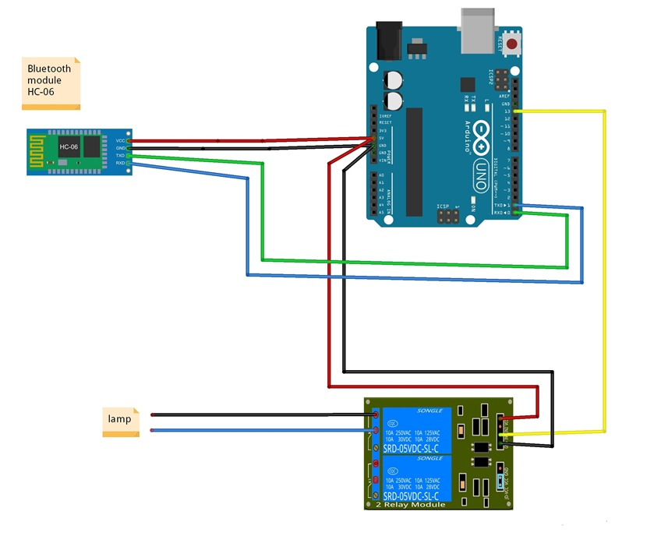

**Concept Used:-**

**1.**This experiment has the use of Bluetooth, Smartphone and the concept of the LED Flasher.

2.In the experiment, we used a Bluetooth IC to make a simple flasher using a single LED.

3.Another is how in this experiment, the Bluetooth IC is to be connected to the Arduino, so that the signals can be easily transferred as well as received.

4. Understanding the concept of Bluetooth and receiving and transferring the data. Some connections need to be made like Connecting Bluetooth to arduino.

5.Concept of Arduino.

**Learning and Observations : -**

1.We use the Arduino and the Bluetooth. The Tx port of Bluetooth is connected to 0 pin of the arduino. The Ground of Bluetooth is connected to the ground of arduino. VCC that is high voltage is connected to the 5V of arduino.

2.The Ground of Bluetooth is connected to the ground of Arduino.

3. The signals will be transmitted from Bluetooth to the arduino.

4. The Bluetooth receives the signals at Rx(0) which is the Receiver, used to receive signals from other devices.

5. The codes are written on the IDE for the working of the experiment.

**Problems and Troubleshooting:**

1.There was a slight confusion in understanding the transmission and receiving of data and then making the required connections.

2.Some minor errors were there, which were trouble shooted by the correcting the code.

**Precautions**

1. One should be careful of the Tx and Rx pins.

2. The coding needs to be correct for the proper functioning of the experiment.

3.The connections made on the pins of the Arduino must coincide with the codes written on the software.

**Learning Outcomes**

Following are some of the learning outcomes-

1.Understanding the concept and connections of Bluetooth and Arduino Board.

2. Having the proper understanding of Tx and Rx.

3.Improvise the learning of the Arduino.